Name: ______________________________________ Period: ___ Date: ______
Determining Specific Heats of Selected Materials
1. Write the formula for specific heat capacity, showing the units for each part.

2. The specific heat capacity of copper is 390 J/kg·C. What does this mean? | 3. Calculate the energy transferred when 3 kg of copper is heated from 20°C to 220°C.
 | 4. Calculate this energy needed to heat 2 kg of water from 10°C to 90°C. The Specific heat capacity of water is 4200 J/kg· C.

5. Complete the table by calculating the missing values.
Materials | Energy Transfer | Mass | Temperature Rise | Specific Heat Capacity
A |  | 4 kg | 6°C | 4000 J/kg·C
B | 6,000 J | 1 kg |  | 2000 J/kg·C
C | 9,000 J |  | 4°C | 1000 J/kg·C
D |  | 12 kg | 24°C | 500 J/kg·C
E | 2,500 J | 2 kg | 5°C

Answer questions 6-9 using the data table below.  Here are the specific heat capacity of four different metals.  Metals Specific Heat Capacity  Aluminum 910 J/kg·C  Brass 380 J/kg·C  Copper 390 J/kg·C  Iron 460 J/kg·C | 6. How much energy must be transferred into 1 kg of copper to raise its temperature by 1°C.
 | 7. Suppose you have 1 kg of each metal. Which one will need the most energy to raise its temperature by 1 °C.
 | 8. The same amount of energy is transferred into 1 kg of each metal. Which one has the largest temperature rise?
 | 9. How much energy must be transferred into 2 kg of iron to raise its temperature by 5 °C.
Use the Data Table below to answer the following questions.
Specific Heats of Selected Materials
Materials | C (J/kg · K)
Substance A | 897
Substance B | 850
Substance C | 509
Substance D | 840
Substance E | 5193
Substance F | 4181

10. Which substance would release thermal energy the slowest? | 11. Which substance would release thermal energy the quickest?
B. Is this substance a conductor or an insulator? | B. Is this substance a conductor or an insulator?
C. Which of the following materials is most likely the unknown substance from Question 10? Circle one  Water Diamond Aluminum Helium Concrete | C. Which of the following materials is most likely the unknown substance from Question 11? Circle one  Water Diamond Aluminum Helium Concrete
12. Using the data table above, rank the substances from those that change temperatures the quickest to those that do not.
_______________ ________________ ______________ ________________ ________________

13. Using the data table above, rank the substances from those with the highest specific heat to lowest specific heat.
_______________ ________________ ______________ ________________ ________________

Use the following 3 images to answer the questions.
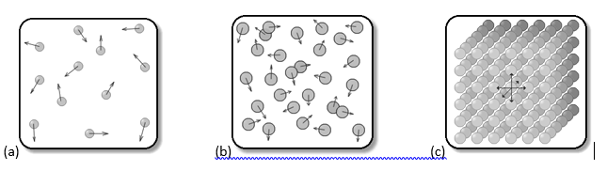

____________ ____________ _____________

14. In the lines above, label each image as being a solid, liquid or gas.
15. What image above shows molecules moving the slowest? ______ Why are they moving so slow?

16. What image would contain the highest amount of thermal energy?
17. If you wanted to change a substance from A to B, what would need to happen? What is this process called?

18. If you wanted to change a substance from C directly to A, what would need to happen? What is this process called?

19. What is happening to the thermal energy as you move from A to B to C? _________________________________
Is this Endothermic or Exothermic
20. What is happening to the temperature as you move from A to B to C? ____________________________________
Is this Endothermic or Exothermic
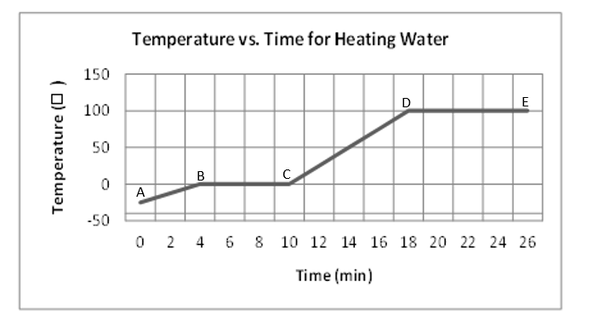
Reading a phase change graph:

21. During what time interval(s) is the thermal energy of the water increasing?

22. At what intervals is the temperature increasing?

23. What intervals show a phase change?

24. What happens from the 18th minute to the end of the data collection?

25. What state of matter is the water between interval A and B?
26. At what degree is the water melting? __________ At what degree is the water boiling? _______
27. What happens from the 4th minute to the 10th minute?

28. Is this graph showing an endothermic or exothermic reaction? ______________

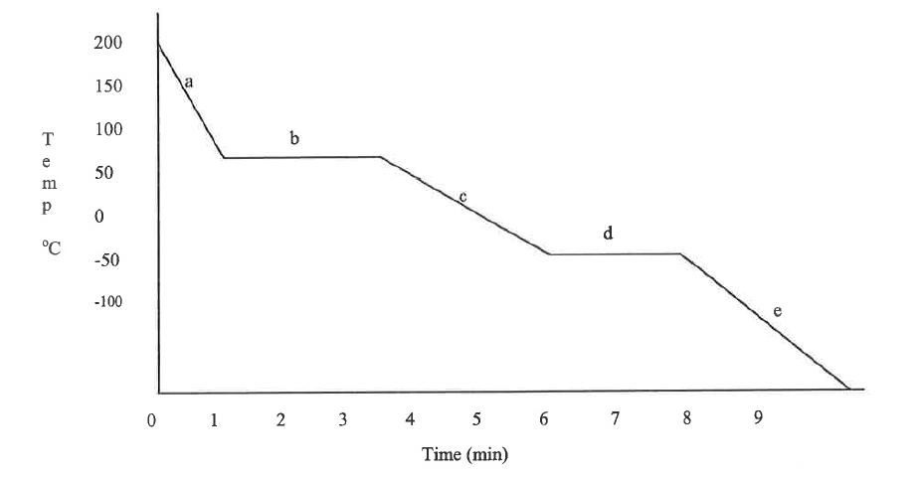

29. Is this graph showing an endothermic or exothermic reaction? ___________

30. Is heat being added or removed from this substance? ______________

31. What segment represents the point during which the gas is turning into a liquid? __________

32. Which segment represents the point during which the liquid is turning into a solid? __________

33. What process is occurring between minutes 1 and 3? _____________________

34. What state of matter is the substance in at the end of segment b? _________________

35. What process is occurring between minutes 6 and 8? ___________________

36. What state of matter is the substance in letter e? _______________

