1. The idea that information flows in one direction is called _______________. | 2. What are the four bases found in a RNA molecule? You must say the whole name for all four to get the point. | 3. Why is RNA necessary to act as a messenger? (Why can't the code be taken directly from DNA?)
4. What process takes DNA and creates another copy of DNA? | 5. During translation, what is transported to the ribosome where they are bind together to create a protein? | 6. How many types of amino acids are there?
7. What is the function of a rRNA? | 8. What amino acid does every strand of mRNA end with, signaling that the protein is done? | 9. Who came up with the central dogma concept?
10. What amino acid does every strand of mRNA start with? | 11. Identify the three processes involved in the central dogma. They must be in the correct order. | 12. In order for the process of translation to being, what kind of codon must be first?
13. What is the complimentary mRNA strand made from this DNA sequence?  DNA Sequence:  ACC-TAG-GTT-AAC | 14. What types of cells have a nucleus? | 15. Explain the process of Translation.
16. Three bases on tRNA which match one mRNA codon is called __________. | 17. Where in the cell does translation occur? You must provide the specific location. | 18. What is the function of DNA?
19. A macromolecule made of amino acids is called? | 20. Who was the first person to see the shape of DNA? | 21. A chain of amino acids linked together by peptide bonds is called? Hint. Proteins is an example.
22. What two processes in the central dogma concept occur inside the nucleus? | 23. In the process where DNA is copied, 2 molecules of DNA are made. Because each molecules contains one old and one new strand, it is called a ________________ process. | 24. Identify the follow structure and state it’s function.
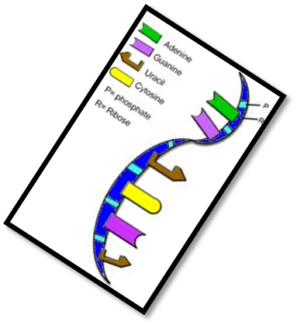  25. Identify the structure below. | 26. What are codons made of? | 27. From the three process involved in the central dogma , which one is NOT part of protein synthesis?
28. What are the two functions of RNA Polymerase during transcription? | 29. A fragment of DNA used as a template to make mRNA is called? | 30. What does RNA stand for?
31. RNA is what kind of macromolecule? | 32. Identify the enzymes that does all the work during transcription. | 33. Anticodons are found on what structure during translation.
34. What is DNA in the shape of? | 35. What is the name of the process that uses one strand of DNA to make a strand of mRNA? | 36. What are the backbones of DNA and RNA strands made of?
37. What is the function of mRNA? | 38. What kind of bonds hold the two strands of DNA together? | 39. Identify structure #2 in the following diagram.  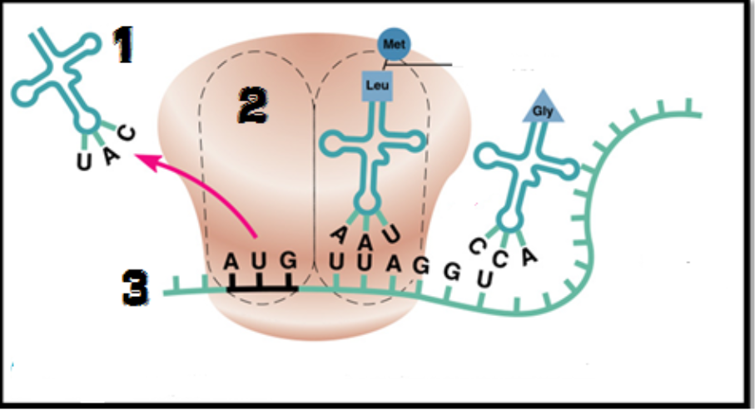
40. An mRNA base sequence is UUA-GCA. The two anticodons complementary to this are: | 41. Identify three major differences between DNA and RNA. | 42. What are the 3 parts of a nucleotide found in RNA?
43. What are the 3 types of RNA? | 44. What type of bonds are formed between amino acids? | 45. How many codons are needed to specify three amino acids?

