Mutations 8.7
- Mutation:
  - Any ______________ in the ______ sequence
  - Can change the ___________ that will then create a different ____________

2 Main Types of Mutation
Gene Mutations | Chromosomal Mutations
Changes occur in a single gene | The number of structure of chromosomes is changed
2 types:  1.  2. | 4 types:  1.  2.  3.  4.

Gene Mutations
1. | One nucleotide is _________________ for another | Example:  Normal: A C T G T T A G C T A  Mutated:
2. | _______________ or _______________ of a nucleotide causes the whole sequence to ________ | Example: Insertion  Normal: THE CAT ATE THE RAT  Mutated:
Example: Deletion
Normal: THE CAT ATE THE RAT
Mutated:

What type of mutation are the following (substitution, insertion, or deletion)
A. B. C.
A T C G G T A C T G C T A A C G T A T A G C C A G GG
A T C G C T A C T G C A T A A C G T A T A C C A G G G
__________________ _________________ _______________

Which of the mutations above would cause a frameshift mutation?

CHROMOSOMAL MUTATIONS
1.) Deletions | Lose ____________ or ________ of a chromosome
2.) Duplications | ____________ parts of a chromosome are made
3.) Inversions | _____________ of chromosome parts are ______________
4.) Translocations | Part of a chromosome ______________ off and ______________ to another

Mutagens:
- Agents in the ________________ that can ___________ _______
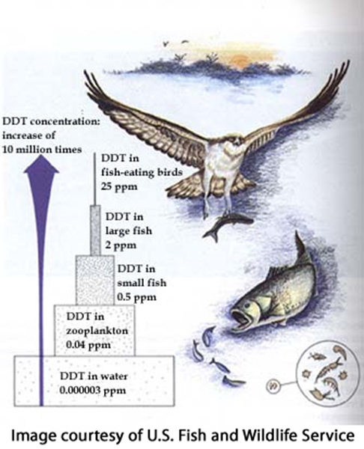
- Mutations may be ________________, _________________, or _______________
  - Ex: UV __________, pesticides & other _____________
- Ecologist warn against the ________________use of ________________and other potential mutagen and ___________
- _______, a pesticide used caused a lot of harmful efforts on _________ and ______________
  - Example:
- _______________________ wrote and book called “______________” warning the community about the ___________________ was having on the environment and human.

What organisms were most affected because of the pesticide DDT?

