[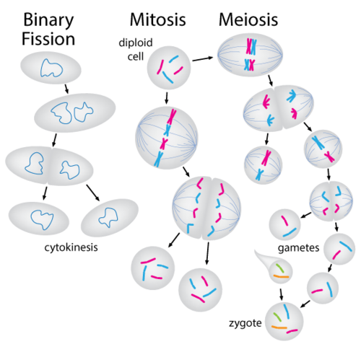](http://www.google.com/url?sa=i&rct=j&q=&esrc=s&source=images&cd=&cad=rja&uact=8&ved=0ahUKEwjw2qbDub3KAhWBWT4KHRk-DEYQjRwIBw&url=http%3A%2F%2Fwww.ck12.org%2Flife-science%2FMitosis-vs-Meiosis-in-Life-Science%2Flesson%2FMitosis-vs.-Meiosis%2F&psig=AFQjCNEWVkUQqamOYas9mEFTTW5c8D92gQ&ust=1453553086816099)