Name:_______________________________________________________________Date__________________________ Period:________
Isotope Practice
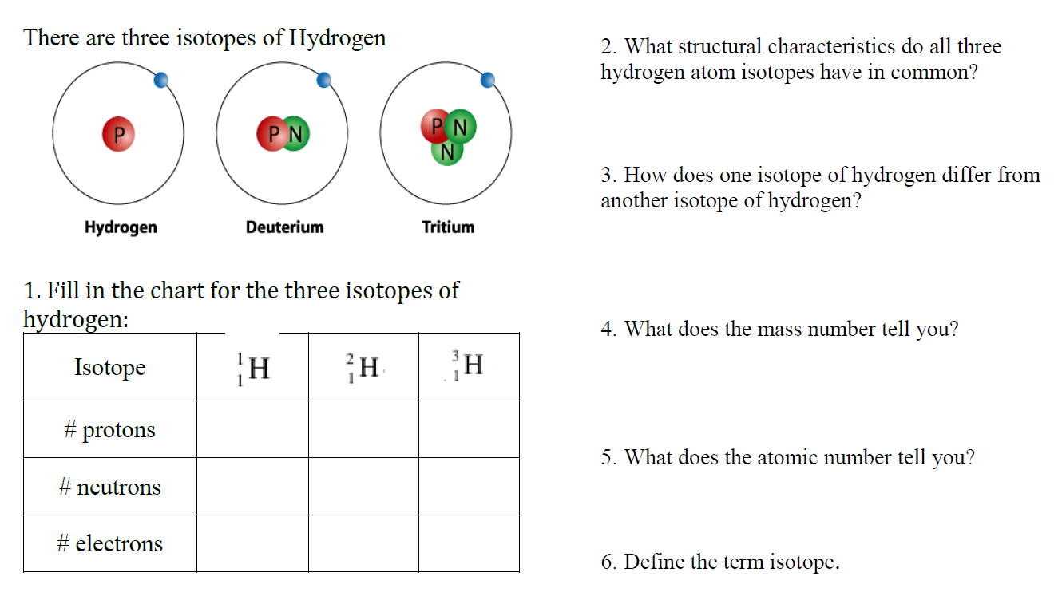

₆
Here are three isotopes of an element: ¹²C ¹³C ¹⁴C
₆
₆
  - The element is: __________________
  - The number 6 refers to the _________________________
  - The numbers 12, 13, and 14 refer to the ________________________
  - How many protons and neutrons are in the first isotope? _________________
  - How many protons and neutrons are in the second isotope? _________________
  - How many protons and neutrons are in the third isotope? _________________

Complete the following chart:
Isotope name | atomic # | mass # | # of protons | # of neutrons | # of electrons
Potassium-37
Oxygen-17
uranium-235
uranium-238
boron-10
boron-11

