Graph #1 Title - .

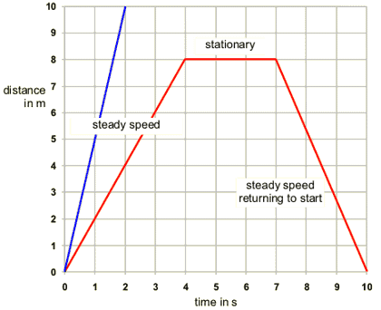
Object A
Object B

- Notice the variables on Graph #1. What is this a graph of? Write the title above the graph.

- Describe the motion of Object B during the first 4 seconds.
- Describe the motion of Object B from t=4 sec to t-7 sec.
- Describe the motion of Object B during the last 3 seconds.
- How does the motion of Object A compare to the motion of Object B?

Graph #2 Title - .

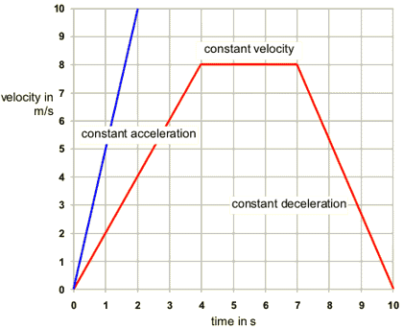
Object A
Object B

- Notice the variables on Graph #2. What is this a graph of? Write the title above the graph.

- Define acceleration.
- Explain three ways an object can accelerate.

- Describe the motion of Object B during the first 4 seconds.
- Describe the motion of Object B from t=4 sec to t-7 sec.
- Describe the motion of Object B during the last 3 seconds.
- How does the motion of Object A compare to the motion of Object B?
- Develop a mathematical model (equation) for calculating acceleration.

