AP Environmental Science Energy Superheroes/Villains
---------------------------------------------------------------------------------------------------------------------------

Overview: With your partners, you will create an energy “superhero” that highlights the advantages and disadvantages of various types of energy. After presenting these super heroes to the class, we will choose the top 5 to be included in an ENERGY LEAGUE that will fight to bring development to the global population while being attentive to issues of climate change and pollution.

Choices: Wind, Natural Gas, Coal, Petroleum, Uranium, Solar, Hydropower, Geothermal, Biomass.

Directions: Part 1
- Read your notes and the resources about your assigned energy source.
- Create and diagram an “Energy Superhero” that highlights the advantages and disadvantages of this type of energy.
- Following components MOST be included in your visual diagram:
  - Superhero – what does he/she look like?
  - Name – who is he/she?
  - Descriptions of main advantages – Think of a creative way to communicate these. This could be done in his/her costume, accessories, dialogue bubbles or other items in your drawing. Identify a main super power that corresponds with its strength.
  - Descriptions of main disadvantages – Think of a creative way to communicate these. This could be done in his/her costume, accessories, dialogue bubbles or other items in your drawing. Perhaps even identify his/her main nemesis.

Organize your drawing in a similar format to the following example:

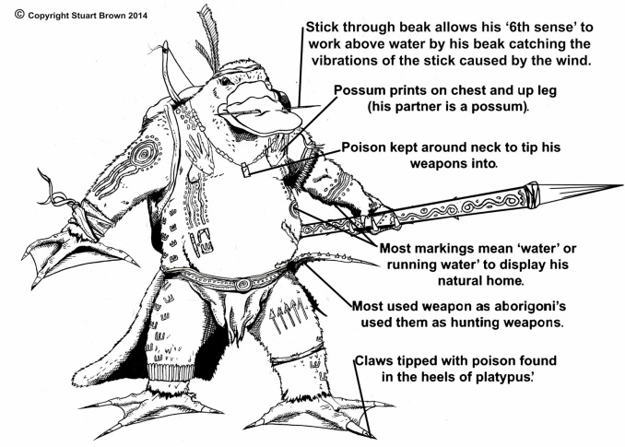

Directions: Part 2

- You will create a book.
- This book must be over two energy sources.
  - 1 Must be Nonrenewable: 1 Must be Renewable.
- It must contain all of the following for each:
- How the energy is produced
- Waste products produced
- Where this type of energy is typically found, used, and/or stored
- Advantages to this type of energy
- Disadvantages to this type of energy
- Interesting facts (efficiency, popularity, statistics, units of measurement, etc.)
- At least 4 pictures/diagrams
- At least 2 graphs
- Works Cited to document your sources and where you got your information
- The book must be have written. The only thing you can print are pictures.
- Make it creative
- How you make it is up to you.

