Earth Science Review
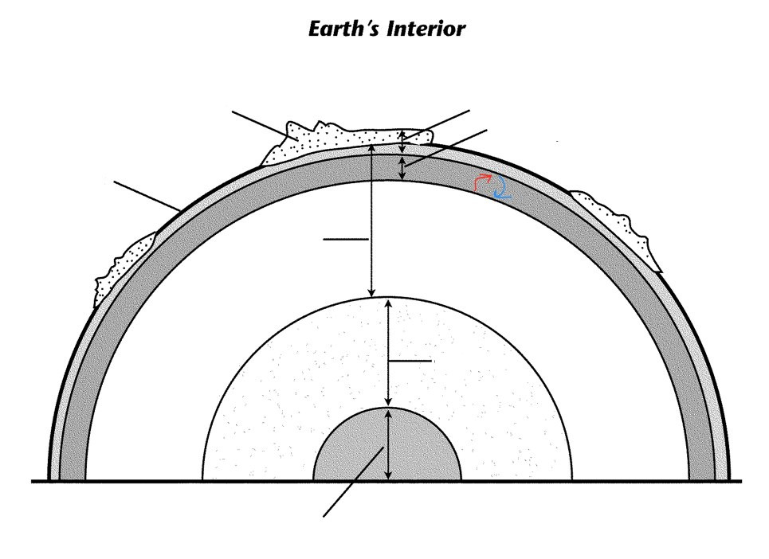
- Label:
lithosphere
outer core
oceanic crust
continental crust
asthenosphere
upper mantel
lower mantle
inner core

T or F
_____. Oceanic crust is older than continental.

_____. Continental crust is less dense and rises above the denser oceanic plate.

_____. The Earth’s plates consist of only the crust.

_____. The Earth’s plates move as result of convection currents in the asthenosphere.

_____. Oceanic crust is mainly composed of granitic type of material.

2. Read the following descriptions and then match the correct letter to the diagram.

- A mid-ocean ridge forms whenever diverging plates continue to separate, creating a new ocean basin. As the rising magma cools, it forms new ocean crust.
- When an oceanic plate converges with a less dense continental plate, the denser oceanic plate sinks under the continental plate.
- When two oceanic plates converge, the denser plate is forced beneath the other plate and volcanic islands forms above the sinking plate.
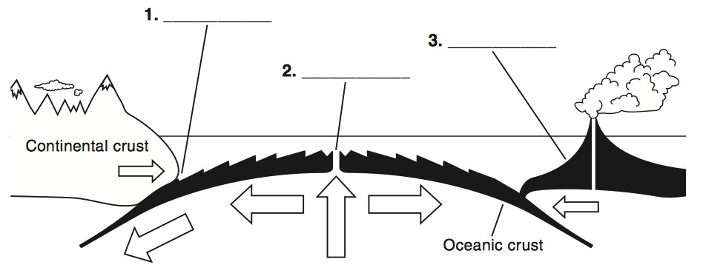

3. Match the letter in the diagram to the following statements.
_______. Molten rocks flows onto the seafloor and hardens as it cools.
_______. Hot, molten rock is forced upward toward the seafloor at a mid-ocean ridge.
_______. New seafloor moves away from the ridge, cools, becomes denser, and sinks.
_______. Molten rock pushes sideways in both directions as it rises, moving the mantle with it.

4. Draw arrows showing a transform boundary.

Name a location of one.

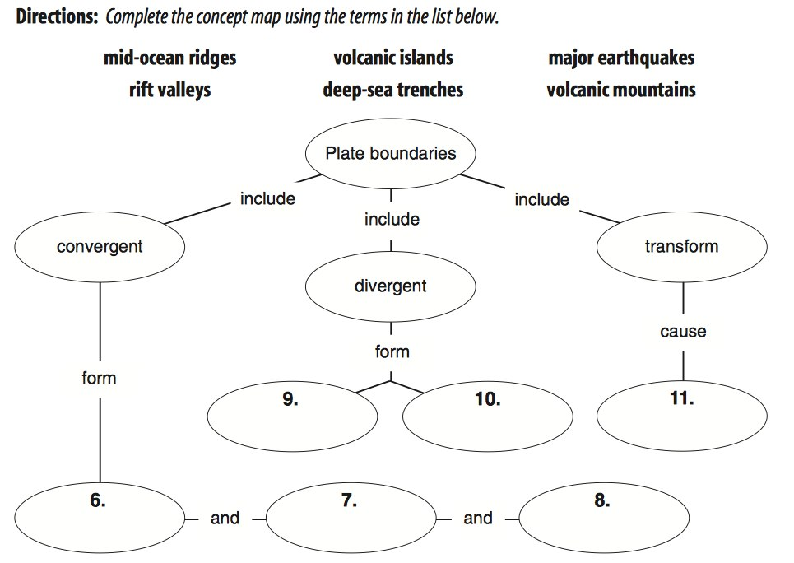
5. Complete the concept map using the terms in the list below.
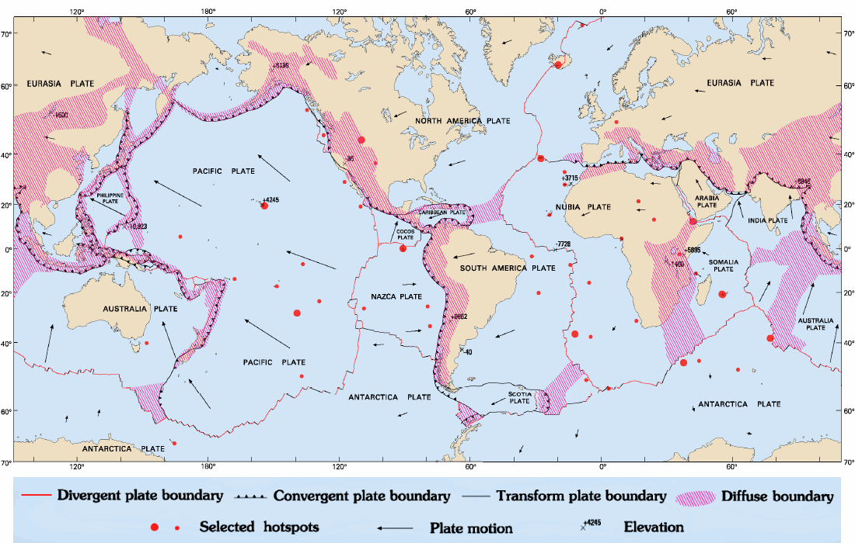

- What is the name of the small crustal plate off the coast of Oregon that is subducting under the North American plate?

- Most volcanoes occur around the Pacific plate and it is known as the Ring of Fire. Explain why.

- Identify the landform created at each type of Convergent boundary and give an example.

  - Ocean-Ocean

  - Ocean-Continental

  - Continental-Continental

- Identify the landform created at each type of Divergent boundary and give an example.

  - Oceanic – Oceanic

  - Continental - Continental

- At what type of boundaries would tsunamis be generated? https://www.e-education.psu.edu/earth501/content/p2_p3.html
Under what other types of conditions could tsunami occur?

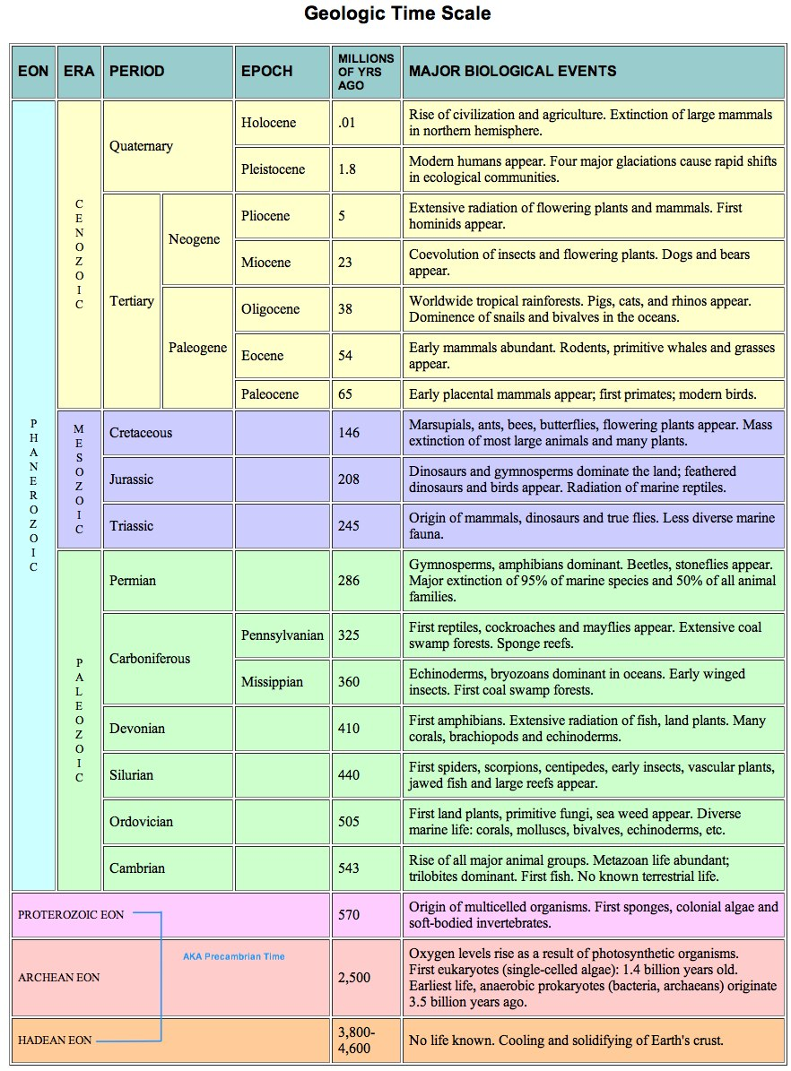
According to the Geologic Time Scale:

During what time did life first begin?

During what period and era where fossil fuels first formed?

What eon, era, period and epoch are we in now?

During what period what period was there a mass extinction including the dinosaurs?

During what epoch did the glaciations take place?

