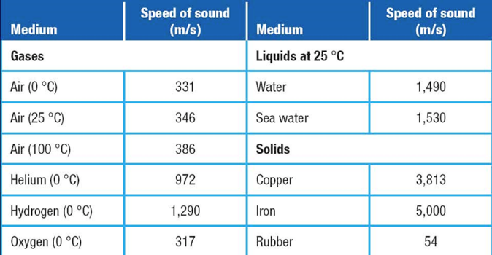
- SOUND & LIGHT
Properties of Sound
- Type of ______________________________
- They are _________________________________
- Move directions ___________ from the source.
- ___________ of sound depends on the __________

Density and Sound
- The _________ of the _______ affects the ____________ at which ___________________ through the medium.
- Mediums that are _________ allow sound to __________________ because the particles are _______________.
- _________________ also affects the _________________________
  - _______ temperature allow sounds to move ________ than __________ temperatures.

Ultrasound and Sonar
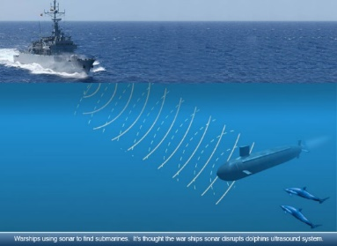
- Like all waves, _______________________________
- The reflection of sound waves can be used to determine distance and to create maps and images
- _________is a system that uses reflected sound waves to determine the distance to and location of objects
- What wave behavior is being used to do this?

Light
- Type of ______________________________
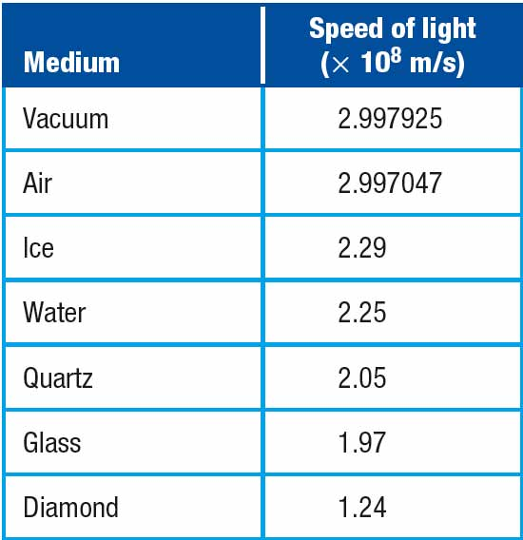
- Light behaves like a ___________________ of energy
- Light can also behave as a ________________________
- Travels without a medium (___________________), but can move ___________________
- The ______________________________ depends on the_______________
  - Travels the fastest in a ___________: ____________________
  - __________ is the fastest signal in the ___________________________________
  - Slows down as ____________ of materials ( _____________) ____________

- Why do we see lightning before we hear it? ___________________________________

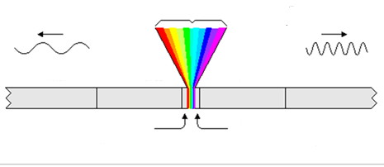
Fill in the Diagram

Electromagnetic Spectrum- Types of light
- EM Spectrum- the range of ____________________or _______________________ over which ____________________________________ extends.
- Waves are classified by their _____________________
  - As wavelength increases, frequency ___________, it contains ________ energy.
  - As wavelength decreases, frequency ___________, it contains ________ energy.
EMS Starting from longest Wavelength to Shortest Wavelength
Which radio station has the shortest wavelength?
- ________________
Atlanta Radio Stations
WRFG 79.3 MHz
WZGC 82.9 MHz
WVEE 101.3 MHz
WYAY 105.7 MHz
  - are used in communication and radar
  - Lowest ______________________________________
  - Ex: ____________________________
- ________________________
  - used in cooking and communication
  - __________________________________over a long distance. (Space to Earth)
- __________________________
  - can be felt as_________________
  - Sun or a heat lamp ___________
  - Weather satellites read (_____________________________) for the tracking of cloud movement

- Visible Light Spectrum
- Light __________________________
- __________________________ – Acronym for remembering the colors of visible light
    - _________________to ________________________________

R- _________________
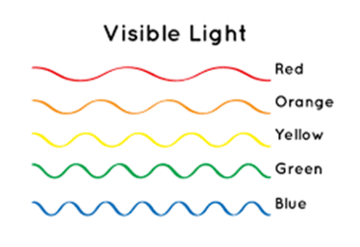
O- _________________
Y- _________________
G-_________________
B-_________________
I-_________________
V-________________
- ______________________
  - has higher energy and shorter wavelengths than ________________________.
  - ___________ contains ultraviolet light (UV rays) (9%)
  - UV rays can pass through thin layers of clouds, causing sunburn.
- _________________
  - X rays has the __________________________ and __________ wavelength.
  - Helpful in ___________ procedures due to being able to pass through our bodies and create _______
  - Harmful in that they can ___________________________
- _________________
  - Gamma rays have the ______________________ and the _____________ wavelengths.
  - Helpful during medical procedures and _____________________________
  - ___________ harmful in that they can also increase cancer rates and ________ good ______________

Doppler Effect
- An observed ______________ in the _____________ of a wave when the ____________ or observer is __________
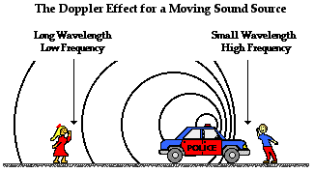
- Occurs in___________ and ______________
- As frequency change, there is a change in ____________ (______________________).
- As frequency changes, there is a change is ______________ (________________)
- Frequency changes when the source _________________________________________
  - Ex.

- What happens to the amount of energy as the ambulance moves farther from the girl?

Fill in the Venn diagram using the following. Place them where they belong.

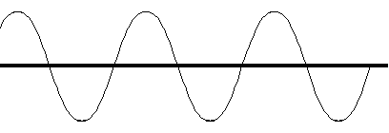
- Transverse Wave
- Longitudinal wave
- Can only travel through a medium
- Can travel through a medium or a vacuum
- Waves that transfer energy
- Speed around 300,000,000 m/s
- Speed around 343 m/s
- Can’t see them
- Can travel through matter
- Can see some of them
- Reflection, and refraction
- Speeds up when they go liquid & solid
- Slows down when passing liquid & solid

Sound Wave Light Wave
Both

