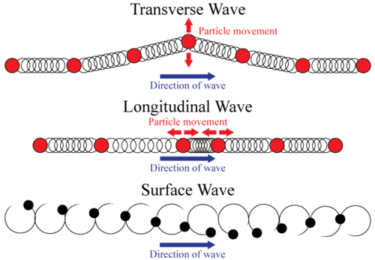
CHAPTER 15 WAVES
Waves
- _______- a disturbance that _____________________through matter or space
- Energy may ________________________________ as a _______________________
- _______________________________ explains differences in ________________________
- The speed of a wave depends on the ______________
  - Medium-_______________________________________________________
  - Ex:
  - Greatest in ____________ and least in ___________
- 2 Types of Waves: 1. ________________________ 2. ______________________________

1. Mechanical Waves
- A wave that ___________________________________ through which to ______________
- They are caused by the ________________________ of __________________ within the ________________
- 3 Types of Mechanical Waves: 1. ___________________ 2. ____________________ 3. __________________
  - ____________ waves (air)
  - ____________ waves
  - waves in a _____________
  - Explain a tsunami wave.

Transverse Wave
- Particles oscillate ______________________________________ about their equilibrium positions, ________________________ to the direction of wave propagation
- Its ____________________________ perpendicular to the ____________________ the wave moves
- Ex:
Longitudinal Wave
- Particles ___________________________ and _______________ about their equilibrium positions, _______________ to the _______________ of wave motion
- ___________________ in the same direction as the wave moves
- Ex:

Surface Wave
- In a surface wave, _______________ move in ______________.
- Combination of __________________and ________________
- Ex:

Wave Properties of a Transverse Wave
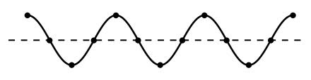

- _____________________-the ______________________ of a transverse wave
- _______________________-the _______________________ of a transverse wave
- A _________________ consists of _________________________and _____________________
- ____________________________-the _____________________________ that particles in a medium move from their _____________________________ when a ________________________________
Wavelength
- ____________________________-the distance between any __________________________________________ of a wave
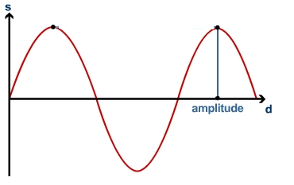
  - Ex:
- Short the ______________________= _____________________________________
Amplitude
- The amount of ____________carried by a _______________
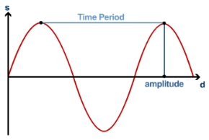
- Large the _____________________ = ________________________
Period
- the time required for one full wavelength to pass a certain point
- complete cycle or wave oscillation to occur
Frequency
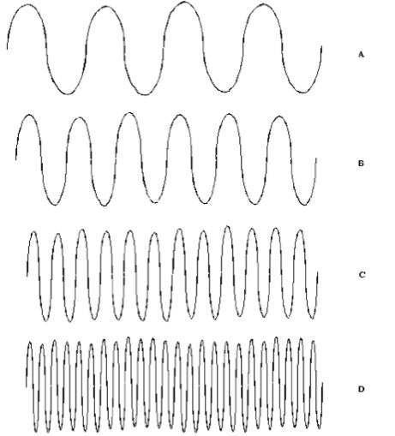
- The number of cycles or vibrations per unit of time.
- The number of waves produced in a given amount of time.
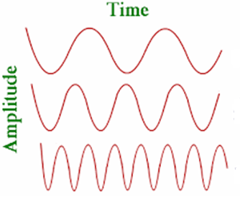

Wave Properties of a Longitudinal Wave
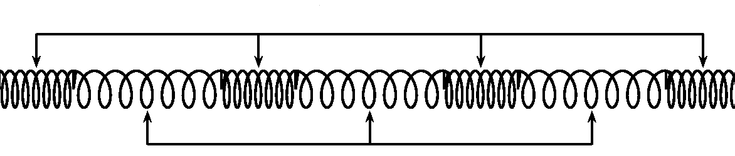

- A cycle consists of one compression and one expansion of the particles of the medium.
- _________________________: the _________________ areas of a longitudinal wave
- _________________________: the _________________ areas of a longitudinal wave
2. Electromagnetic Wave
- Wave caused by a disturbance in _____________________________________________ by ______________________________ particles.
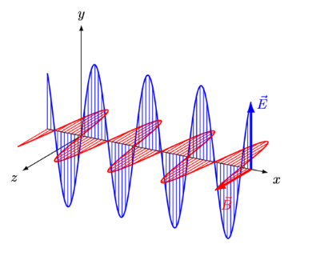
  - Does not require a ______________
  - Also called a ___________________________
  - can transfer energy through a _____________
  - can also transfer energy through a _____________________________
  - Ex.
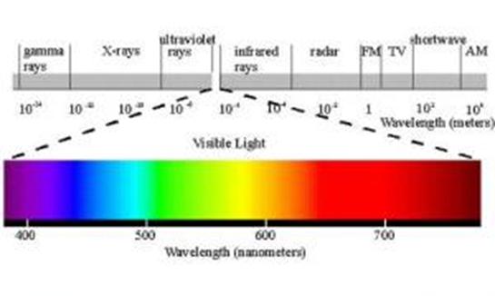

Wave Interactions
- Waves bend when they pass from ______________________________ to ____________________________

Wave Interaction Type | Details | Diagram
1. | The _______________________________ of a wave as it meets a __________________ or __________________  Ex:
2. | The _______________________ of a wave as it __________________________________________  Ex:
3. | The _________________ of waves as they pass from ______________________________ to _______________.  All waves are _____________________ when they pass from ________________________ to another at _________________________  Ex:
4. | The_______________________________ of two or more _________________________________ in the same place at the ________________________  Occurs in _____________________________  Ex:
Type 1:
- Waves _____________________________ any phase difference
- Waves combine to form a ______________________________
- Increases _______________________
Type 2:
- Waves combine differing by multiples of ___________________________
- waves combine to form a __________________________ than the largest of the original waves
- ______________________amplitude

