**Chapter 13.3 & 13.4**

**Energy Transformation Notes**

**Energy**

* **What is Energy?**
* ________ is measured in _____________
* 2 Types of Energy:

____________________

____________________

|  |  |
| --- | --- |
| **What Forms of Energy Are There?** | |
| 1. **Potential Energy** | 1. **Kinetic Energy** |
| * Energy that is _____________ as a result of _________ or _________. * Energy in a _____________________________   + Ex: Stretched rubber band, ______________ * Can increase by increasing:   + __________, ____________ ___________ or _________________ | * The ____________________________________ * Depends on two things   + _____________ and _____________ * Kinetic energy depends on _________ more than ___________. |
| 1. Describe the energy transformation from A. to B. 2. Describe the energy transformation from B. to C 3. Describe the energy transformation from C. to D. | |
| 1.  2.  3. | 1.  2.  3  4.  5. |
| How can you remember them all? | |

|  |  |  |  |  |
| --- | --- | --- | --- | --- |
|  | **Type of Energy** | **Mnemonic** | **Details** | **Examples** |
| 1. |  |  | Energy stored in the ______ of ______ and ___________ |  |
| 2. |  |  | Energy stored in the ___________ of an ______. The energy that holds the _____________________ |  |
| 3. |  |  | Any time ___________ supplies the _________  Higher the ____________= more gravitational energy.  Dependent on its ________, its ________, and the __________________________. |  |
| 4 |  |  | Electromagnetic energy that _______ in ______________________ |  |
| 5. |  |  | Movement of ___________ |  |
| 6. |  |  | The movement of a substance from ___________________________  The sum of the ______________ and ____________________ an object uses to ________________  An object in _____________ |  |
| 7. |  |  | Movement of energy through ______________ in ___________ |  |
| 8. |  |  | The ____________ or movement of __________________________ |  |

**For the following images, identify how energy has been transformed.**



**Energy Transformation**

* The process of changing energy from one form to another is __________________________**.** 
  + Ex: ______________________

**Law of Conservation of Energy**

* States:
  + Energy can’t be ______________ or_________________________ but it does change from _____________________________________.
  + Same _________
* The total energy remains ____________, it just _______________________

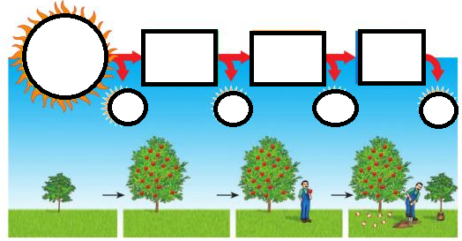

|  |  |  |
| --- | --- | --- |
| **Heat can be transferred 3 different ways** | | |
| **Type** | **Details** | **Picture** |
| 1. | •Transferred of energy by _____________________  •Works best in some _____, then liquids, and _____________________. |  |
| * ______________- materials that allow heat to pass through them   Ex. | |
| * ______________- materials that don’t let heat pass through them well   Ex. | |
| 2. | •Transferring ___________ by _______________  •_______________ and ____________ are fluids  •When heated they ________, become less _________  •They ________, replaced by ________________ fluids  •Make a circular flow called a _________________ |  |
| 3. | •Energy transferred by __________________________  •Ex: infrared radiation, ____________, ultraviolet rays  •Can travel through __________________  ___________  •When wave hit object they make _______________________________. |  |

Review:

* Why does hot air rise and cold air sink?
* Why are boilers placed beneath hot water tanks in people’s homes?
* Radiation travels in straight lines True/False
* Radiation can travel through a vacuum True/False
* Radiation requires particles to travel True/False
* Radiation travels at the speed of light True/False
* Radiation requires a medium to travel True/False